Piscataqua Region Estuaries Partnership PREPA Grants
2024 Request for Proposals

REQUEST FOR PROPOSALS: Piscataqua Region Environmental Planning Assessment
The Piscataqua Region Estuaries Partnership (PREP) invites proposals from municipalities, watershed groups, and partnering organizations within the Piscataqua Region Watershed (see Appendix A.) for projects resulting in achievement of:
- One or more of the proposed actions for their community identified in the 2020 Piscataqua Region Environmental Planning Assessment (PREPA);
- planning or regulatory projects to protect natural resources and/or water quality; or
- projects related to climate vulnerability, adaptation, and/or preparedness.
Visit https://prepestuaries.org/resources/prepa/ to review results by municipality from the 2020 assessment.

PREP is one of 28 U.S. Environmental Protection Agency’s National Estuary Programs, a joint local/state/federal program established under the Clean Water Act with the goal of protecting and enhancing nationally significant estuarine resources – including the Great Bay and Hampton-Seabrook Estuaries. As a watershed-based organization, PREP and its grant funding opportunities support the 52 municipalities across the Piscataqua Region Watershed (Appendix A). Funds for this grant opportunity are provided by EPA under the Bipartisan Infrastructure Law, and the grant program timeline assumes no disruption to anticipated funding cycle.

For 2024-2025 projects, eligible applicants may submit proposals requesting up to $25,000 in grant funding. A total of $100,000 is available for projects for 2024-2025. Applicants may request funding between $5,000 and $25,000 per project. Applicants are required to budget a minimum of 15% for community engagement. For example, a project seeking $25,000 in grant funding must allocate at least $3,750 of grant funding toward community engagement. Applicants are required to outline how the project will advance diversity, justice, and inclusion as part of the application. Contact Community Engagement Manager, Abigail Lyon, if you’d like to discuss this requirement further.

ELIGIBILITY
Municipalities, watershed groups, and organizations partnering with one or more municipalities in the Piscataqua Region Watershed (Appendix A). Watershed groups and organizations may submit more than one application if partnering with more than one municipality.

Example projects and average costs are listed below. If you’d like to discuss a project idea, please contact Abigail Lyon (Abigail.Lyon@unh.edu or (603) 862-3729).
- Adopt or increase buffer or setback regulations for wetlands, vernal pools, streams, buildings, or septic: $10,000-$15,000
- Complete a Natural Resource Inventory or Assessment for Master or Comprehensive Plans: $20,000
- Adopt or update an Open Space Plan: $15,000
- Adopt updated stormwater management regulations or ordinance: $10,000-$20,000
- Adopt updated model floodplain management standards that exceed the minimum federal regulations required to participate in the National Flood Insurance Program (NH Office of Strategic Initiatives Menu of Higher Floodplain Regulation Standards or Maine Floodplain Management Program): $15,000
- Incorporate sea-level rise and climate change planning into Master or Comprehensive Plans or as separate chapters: $10,000-$15,000
- Complete the Maine Flood Resilience Checklist: $5,000

REQUEST FOR PROPOSAL TIMELINE
February 26, 2024: Request for Proposals released by PREP.
February 26-April 26, 2024: Municipal officials (e.g., Planning Boards and/or Conservation Commissions) meet with consultant(s) to determine which project a municipality wants to pursue. Complete the application, review, and sign off on grant requirement documents (9 weeks).
April 26, 2024: Proposal Deadline - submit project application (PDF) by email (Abigail.Lyon@unh.ed) to PREP by 4 PM EST.
April 29-May 15, 2024: Proposal review and selection process (2.5 weeks).
May 16, 2024: Awards announced.
June 3, 2024: Projects begin.

PROJECT TIMEFRAME
Projects should be 12 to 18 months in duration and are expected to begin June 3, 2024 and conclude no later than December 12, 2025. This timeline assumes no disruption to anticipated funding cycle.

PROPOSAL REQUIREMENTS
- Proposal summary form—Contains succinct information about the proposed project. PREP template must be used (Appendix B).
- Project budget form—Submit a Project Budget Form (Appendix C). Identify your qualified consultant for this project.

An electronic copy (PDF) must be received by Abigail Lyon via email (Abigail.Lyon@unh.edu) no later than 4 PM EST on Friday, April 26, 2024. Faxed proposals will not be accepted.

Direct questions to Abigail Lyon, PREP Community Engagement Manager, at (603) 862-3729 or Abigail.Lyon@unh.edu. Questions and answers will be shared online at https://prepestuaries.org/resources/prepa-grants/ up until April 26.

APPENDICES
Appendix A: Piscataqua Region Watershed map (not to be included in proposal submissions)
Appendix B: Proposal Summary Form
Appendix C: Project Budget Form

Appendix A: Piscataqua Region Watershed map
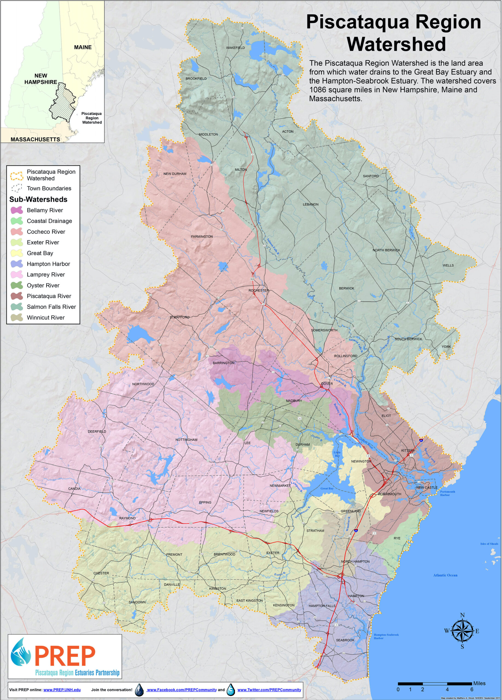

Appendix B: Proposal Summary Form (not to exceed five pages; exclusive of budget)

Municipality/ies/Watershed Group/Organization: ___________________________________________

Name of Applicant(s): _________________________________________________________________

Project Title: ________________________________________________________________________

Phone Number: _________________________ Email: _______________________________________

PREP Funds Requested: ______________________ Total Project Cost: __________________________

Project Summary: Provide a brief summary of the project overall including the project goal.

Connection to the 2020 Piscataqua Region Environmental Planning Assessment Action Items: Identify which of the 2020 PREPA actions the project will address or advance (i.e., adopting primary structure setbacks). If the proposed project does not advance a community specific action from the 2020 Piscataqua Region Environmental Planning Assessment, describe how the project protects natural resources or water quality.

Project Task Timeline: Identify project tasks and dates from start to finish. Specify in your timeline if your municipality requires a public hearing and/or town meeting vote to implement the project. (Keep in mind projects are expected to start June 3, 2024 and be completed by December 12, 2025. Adoption of new or updated regulations can occur outside the project period.)

Project Team: Identify roles and responsibilities for members of the project team.

Project Deliverable(s): Identify anticipated deliverables for the project. Examples include but are not limited to draft ordinance or regulation language, products to support community engagement, draft chapter language, etc. Deliverables must include a final report after project completion submitted no later than December 12, 2025; reporting template will be provided to awarded proposals.

Why is this the right time for this project? Does this project build on previous efforts? Why is your town ready? Will the project address priorities or needs identified by your community or the region? If so, how? For example, the Town has identified the need, is willing to make the municipal investment, Town board and/or public is ready for new policy, Town has the staff capacity to complete and implement project, project addresses a recommendation from the community in the Master/Comprehensive Plan, Climate Vulnerability Assessment/Hazard Mitigation Plan, etc.

Describe your approach to community engagement. How will the minimum 15% budgeted for community engagement be used to support public input, share project results, generate support for a regulation or zoning update and/or change behavior? How will your approach promote diversity, equity, justice, and inclusion? For example, using new approaches to gather input from a diverse set of community members, bringing new voices into local decision-making, addressing an environmental issue that impacts historically underserved populations, etc.

☐ Is this project part of a multi-town effort? If checked, specify towns.
_________________________________________________________________________________________

Appendix C: Proposal Budget Form

Municipality/Applicant:
 | Amount Requested from PREP | Other Funds* | Total Budget
BUDGET CATEGORIES
Qualified Consultant Fee
Communications & Outreach** (e.g., for a stormwater regulations project ($20,000) budget a minimum of $3,000 (15%) for community engagement)
Supplies /Materials***
Equipment
Travel
Other Cost (specify in space below)
TOTAL PROJECT COSTS

This funding opportunity has no match requirement. Preference will not be given to projects that include match.
* Other funds include federal funds or other non-federal funds that cannot be counted as match. Funds listed here could be used to show support from the municipality
**PREP requires a minimum of 15% of funding be allocated for community engagement for all projects.
***Supplies/Materials includes consumable items, such as field and lab supplies, office supplies, and postage.

______________________________________________
(Signature of applicant)

_____________________________________________ ____________________________ ____________
(Print name) (Title) (Date)

______________________________________________
(Signature of Select Board Chair or Town Administrator)

___________________________________ __________________________________ ________________
(Print name) (Title) (Date)

