|  |
| --- |
| **2025-2026 PREPA Grant Program Request for Proposals** |

**REQUEST FOR PROPOSALS**

The Piscataqua Region Estuaries Partnership (PREP) invites proposals from:

* **Municipalities in the Piscataqua Region Watershed**
* **Watershed groups and/or organizations partnering with municipalities in the Piscataqua Region Watershed**

for projects between $5,000 and $25,000 in scope aimed at protecting their natural resources and water quality, as well as those preparing for and adapting to climate change. A total of $100,000 is available for projects for 2025-2026. **DEADLINE: March 31, 2025**

These projects could involve:

* Achievement or significant progress toward achievement of one or more of the proposed actions for their community identified in the Piscataqua Region Environmental Planning Assessment (PREPA).
* Planning, regulatory, or outreach projects to protect natural resources and/or water quality.
* Projects related to climate vulnerability, adaptation, and/or preparedness.

**For all projects, a minimum of 20% must be budgeted for community outreach and engagement.** For example, a project seeking $25,000 in grant funding must allocate at least $5,000 of grant funding toward community outreach and engagement. **In addition, all applicants are required to outline how the project will support diversity, justice, and inclusion as part of the application. For a full description of the grant program (including FAQs), please visit:** [**https://prepestuaries.org/resources/prepa-grants/**](https://prepestuaries.org/resources/prepa-grants/)

**ELIGIBILITY**

The PREPA Grant Program provides funding opportunities to any of the 52 cities and towns in the Piscataqua Region Watershed in both Maine and New Hampshire, and watershed groups and organizations partnering with one or more municipalities. Watershed groups and organizations may submit more than one application if partnering with more than one municipality **(SEE Appendix A: Piscataqua Region Watershed Map).** A watershed is an area of land where all the water from rain and snow drains into a common body of water, such as a river, bay, or ocean.

**YOUR PROJECT’S TIMEFRAME**

**Projects should be 12 to 18 months in duration and are expected to begin on or before August 1, 2025 and conclude no later than December 18, 2026.** This timeline assumes no disruption to the anticipated funding cycle.

**REQUEST FOR PROPOSAL TIMELINE**

**November 1, 2024**: Request for Proposals released by PREP.

**November 2024 – March 2025**: Municipal officials (e.g., Planning Boards and/or Conservation Commissions) meet with consultant(s) to determine which project a municipality wants to pursue. Complete the application, review, and sign off on grant requirement documents.

**January 15, 2025:** 2025 PREPA Grant Webinar: How to Apply and Make an Impact in Your Community, an informational PREPA Grant webinar held on Zoom from 10AM-11:30AM EST.

* [**Register for our webinar!**](https://docs.google.com/forms/d/e/1FAIpQLSf_6wQS4so1AQlqQiW6g9gW3LS1aF2Zf0dfyeekWbaPqavFew/viewform)

**February & March 2025:** Support Office Hours held by PREP to support applications and questions (exact days and times are forthcoming).

**March 31, 2025**: Proposal Deadline - Submit all required project application materials in PDF format by email to **Abigail Lyon ([Abigail.Lyon@unh.ed](mailto:Abigail.Lyon@unh.edu)u) by 4 PM EST.**

**April 2025**: Proposal review and selection process.

**May 2, 2025:** Notification of award decisions.

**On or before August 1, 2025:** All projects under contract.

**PROPOSAL SUBMISSION REQUIREMENTS**

1. **Submit the PROPOSAL NARRATIVE as a PDF (enclosed)**—Contains succinct information about the proposed project. You must use the PREP Proposal Narrative form provided.
2. **Submit the PROPOSAL BUDGET & SIGNATURES FORM as a PDF (enclosed)**—Complete the Project Budget Form about your project. Identify your qualified consultant for this project. Obtain applicant and town signatures. You must use the Proposal Budget & Signatures Form provided.

**An electronic copy of BOTH DOCUMENTS must be received by Abigail Lyon via email (Abigail.Lyon@unh.edu) no later than 4 PM EST on Monday, March 31, 2025. Faxed and mailed proposals will not be accepted.**

**SUPPORT FOR YOUR PROJECT**

We're here to assist you every step of the way—before, during, and after the application process. **Questions can be directed to Abigail Lyon, PREP Community Engagement Manager, at any time. (603) 862-3729 or Abigail.Lyon@unh.edu.**

**Register:** [**2025 PREPA Grant Webinar: How to Apply and Make an Impact in Your Community**](https://docs.google.com/forms/d/e/1FAIpQLSf_6wQS4so1AQlqQiW6g9gW3LS1aF2Zf0dfyeekWbaPqavFew/viewform) **On January 15, 2025 from 10AM-11:30AM (EST), we’re hosting a PREPA Grant Program webinar on Zoom.** In this session, we’ll break down the fundamentals about the application process, funding amounts, hear from funded applicants, and answer all your questions during a Q&A session. The session will be recorded.

**PROJECT INSPIRATION & BUDGET GUIDANCE**

Project topics often include:

* **Shoreland Protection:** Safeguarding areas along shores and rivers.
* **Freshwater Wetlands**: Preserving wetlands that provide essential ecological benefits.
* **Stormwater Management and Erosion Control:** Managing rainwater and preventing soil erosion.
* **Climate Adaptation & Resilience:** Preparing for and adapting to climate changes.
* **General Actions for the Watershed:** Efforts to improve water quality, protect natural resources, and build climate resilience. For example, land conservation, increasing vegetative buffers, or adopting fertilizer regulations.

Additionally, PREP conducts and updates an assessment (called The Piscataqua Region Environmental Planning Assessment (PREPA)) that does the leg work of identifying gaps or inconsistency in water quality and natural resource protections in our entire region, organized by town.

The assessment includes both regulatory and non-regulatory approaches to resource management. By looking up the data for your specific city or town, you can use that analysis as inspiration for your project.

**To access the PREPA Assessment for your town**

1. **Visit** [**https://prepestuaries.org/resources/prepa-grants/**](https://prepestuaries.org/resources/prepa-grants/)
2. **Scroll down to the “Get Ideas for your grant: explore the data by Municipality in the PREPA Assessment” section. Then, click the blue “Choose Municipality” button.**

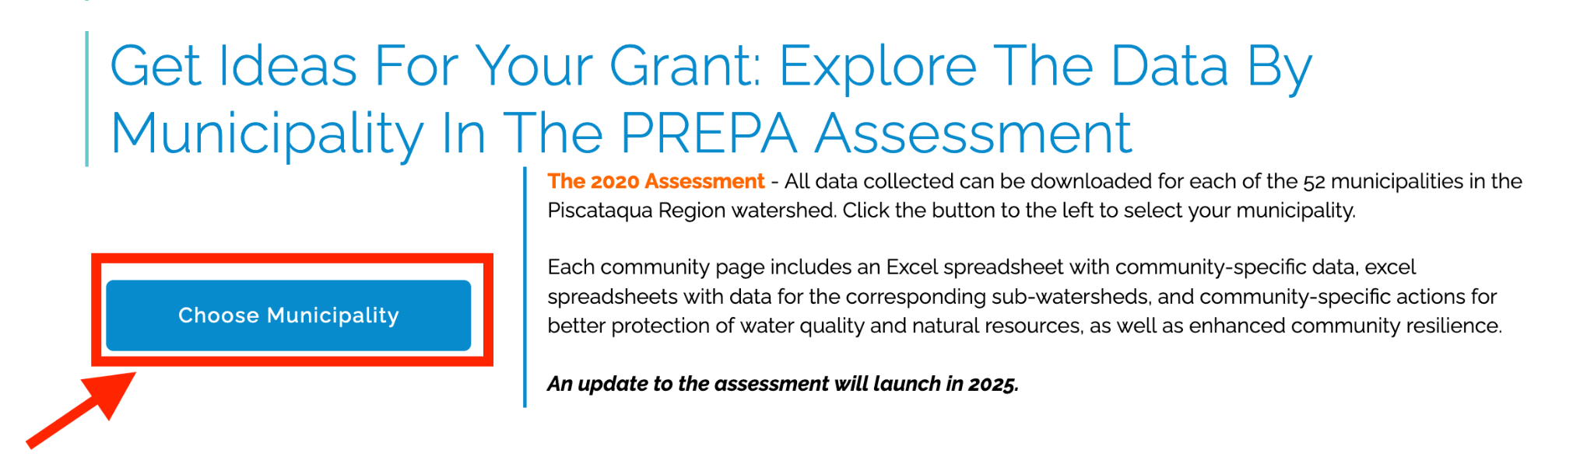

1. **A blue side bar will appear. Locate and click on your city/town. If you don’t immediately see your town/city, use the scroll bars to adjust the visible options.**

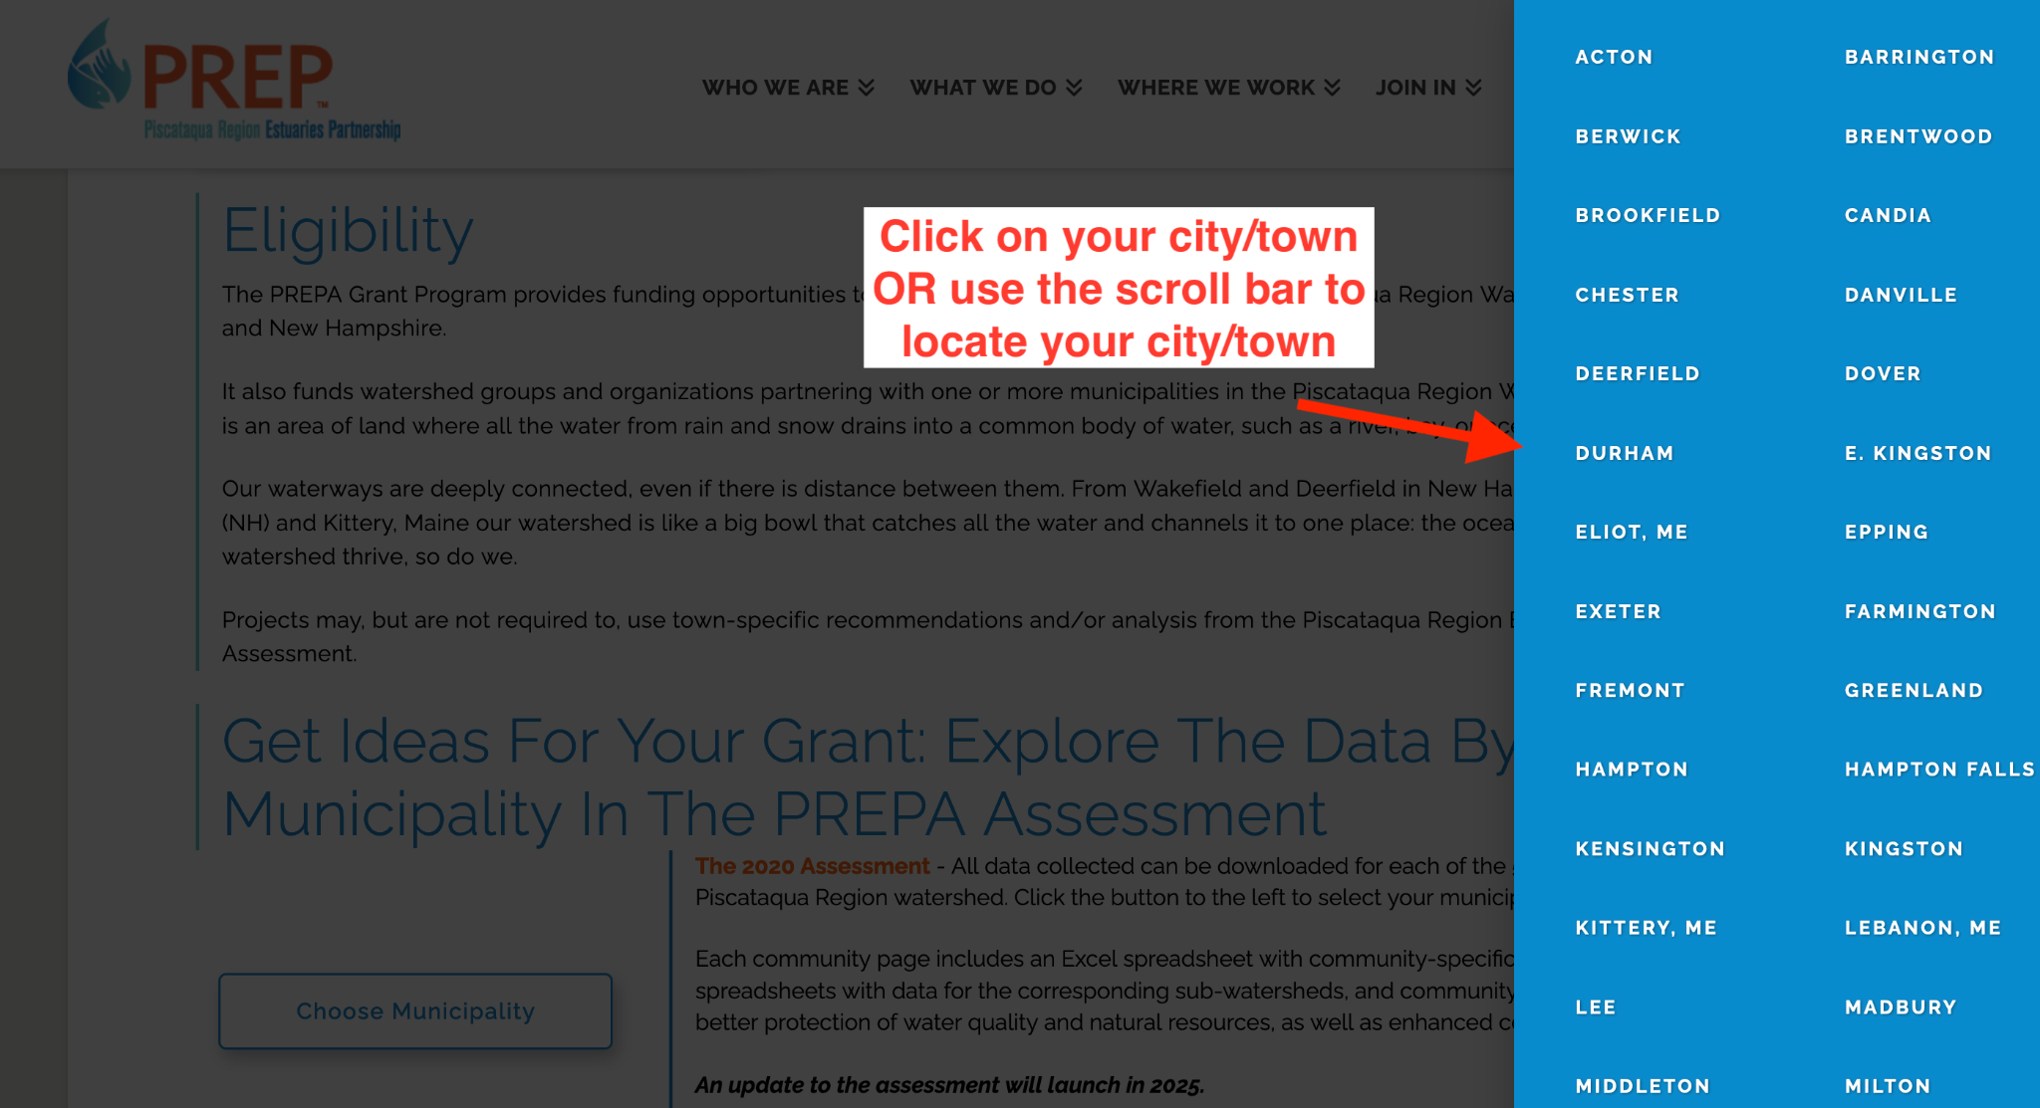

1. **A new page will load with recommendations specific to your town, as well as the option to download the assessment data.**

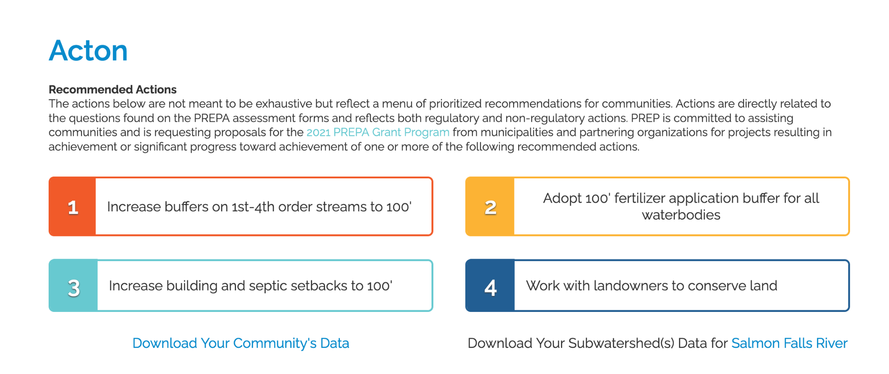

**Budget Guidance**  
To help applicants develop a realistic budget and scope for their projects, we’ve provided a range of sample projects and their associated costs. Example projects and average costs are listed below.

* Adopt or increase buffer or setback regulations for wetlands, vernal pools, streams, buildings, or septic: $10,000-$15,000
* Complete a Natural Resource Inventory or Assessment for Master or Comprehensive Plans: $20,000
* Adopt or update an Open Space Plan: $15,000
* Adopt updated stormwater management regulations or ordinance: $10,000-$20,000
* Adopt updated model floodplain management standards that exceed the minimum federal regulations required to participate in the National Flood Insurance Program ([NH Office of Strategic Initiatives](https://www.nh.gov/osi/planning/programs/fmp/regulations.htm) [Menu of Higher Floodplain Regulation Standards](https://www.nh.gov/osi/planning/programs/fmp/documents/menu-higher-standards.pdf) or [Maine Floodplain Management Program](https://www.maine.gov/dacf/flood/whichord.shtml)): $15,000
* Incorporate sea-level rise and climate change planning into Master or Comprehensive Plans or as separate chapters: $10,000-$15,000
* Complete the [Maine Flood Resilience Checklist](https://digitalmaine.com/mgs_publications/521/): $5,000

**ABOUT PREP**

[**The Piscataqua Region Estuaries Partnership (PREP)**](https://prepestuaries.org/) is a collaborative-driven local organization and National Estuary Program. We are dedicated to protecting and restoring our region’s waterways and estuaries. We believe our 52-community watershed can have it better. We work with towns, researchers, and local organizations to offer scientifically-

informed solutions to improve the health of our waters.

Through region-wide collaboration and a non-regulatory approach, we’re here to tackle big clean water challenges. We are not an advocacy organization and do not impose regulation. We offer grant funding, process facilitation, workshops for skills-based planning, and outreach (like community building and project guidance). We also conduct habitat restoration to help our ecosystem bounce back, monitor our estuaries–from eelgrass acreage data to water temperature and plankton samples–and publish publicly available data about health trends that impact the entire watershed. We are housed within the [**School of Marine Science and Ocean Engineering at University of New Hampshire**](https://marine.unh.edu/) and are part of the [**National Estuary Program (NEP)**](https://www.epa.gov/nep), a place-based program to protect and restore 28 estuaries of national significance. Funds for this grant opportunity are provided by the Environmental Protection Agency under the [**Bipartisan Infrastructure Law**](https://www.epa.gov/infrastructure/national-estuary-program-bipartisan-infrastructure-law-implementation-memo#:~:text=The%20Bipartisan%20Infrastructure%20Law%20specifically,fiscal%20years%202022%20through%202026.), and the grant program timeline assumes no disruption to anticipated funding cycle.

**APPENDIX**

**Appendix A: Piscataqua Region Watershed Map (not to be included in proposal submissions)**

**APPLICATION**

1. **Proposal Narrative**
2. **Proposal Budget & Signatures Form**

**Appendix A: Piscataqua Region Watershed Map**

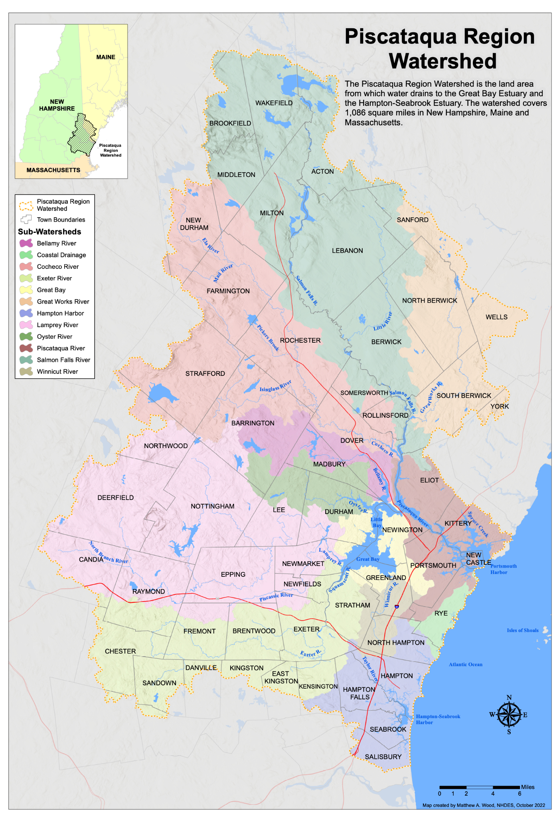

**PROPOSAL NARRATIVE**

|  |
| --- |
| **Before you begin:**  Your Proposals Narrative responses should not exceed five (5) pages; the Proposal Budget & Signatures Form is not included in the 5-page maximum.  As you approach this project, consider how PREP’s values can shape your work:   * Focus on building partnerships rooted in trust, inclusivity, and mutual interest, reaching out to connect with community members in accessible ways. * Bring diverse perspectives and experiences to the table to identify solutions that address local challenges. * Prioritize ways your community can use data you might collect to inform your communities decisions and/or actionable, impactful outcomes.   **Have questions on how to address the above?**   * We’re hosting an informational webinar on January 15, 2025 from 10AM-11:30AM EST over Zoom. [**Register for our webinar!**](https://docs.google.com/forms/d/e/1FAIpQLSf_6wQS4so1AQlqQiW6g9gW3LS1aF2Zf0dfyeekWbaPqavFew/viewform) * We’re also always available to discuss your project at any stage.  **Contact: Abigail Lyon (**[**Abigail.Lyon@unh.edu**](mailto:Abigail.Lyon@unh.edu)**)** or (603) 862-3729. |

|  |  |
| --- | --- |
| **Municipality/ies/**  **Watershed Group/Organization:** |  |
| **Name of Applicant(s):** |  |
| **Project Title:** |  |
| **Phone Number:** |  |
| **Email:** |  |
| **PREP Funds Requested:** |  |
| **Total Project Cost:** |  |

|  |
| --- |
| **1. Project Summary: Provide a brief summary of your project, highlighting 1) the overall goal and 2) how it supports your community's ability to make informed decisions toward cleaner water. We're open to hearing new ideas in your approach.** |

|  |
| --- |
| **2. Connection to the** [**Piscataqua Region Environmental Planning Assessment recommended actions**](https://prepestuaries.org/resources/resources-for-towns/)**: Identify which of the PREPA recommended actions the project will address or advance (i.e., adopting primary structure setbacks).** If the proposed project does not advance a community specific action from the Piscataqua Region Environmental Planning Assessment, describe how the project protects natural resources, water quality, or advances climate resilience. |

|  |
| --- |
| **3. Project Task Timeline: Identify project tasks and dates from start to finish. In your timeline, please include any necessary steps for local engagement—such as public hearings or town meetings—that may be required in your project or may influence the project’s progress.** (Keep in mind projects are expected to start on or before August 1, 2025, and be completed by December 18, 2026. Adoption of new or updated regulations can occur outside the project period.) |

|  |
| --- |
| **4. Project Team: Identify roles and responsibilities for members of the project team.** |

|  |
| --- |
| **5. Project Deliverable(s): Identify anticipated deliverables for your project.** Examples include but are not limited to draft ordinance or regulation language, products to support community engagement, draft chapter language, etc. Deliverables must include a final report after project completion submitted no later than December 18, 2026; reporting template will be provided to awarded proposals. |

|  |
| --- |
| **6. Why is this the right time for this project? Why is your town ready? How does your project respond to current issues or goals in a way that will be meaningful and actionable for your community? What could be impacted if your project is delayed, and how will immediate action benefit your community and/or region both now and in the future?** For example, the Town has identified the need, is willing to make the municipal investment, Town board and/or public is ready for new policy, Town has the staff capacity to complete and implement project, project addresses a recommendation from the community in the Master/Comprehensive Plan, Climate Vulnerability Assessment/Hazard Mitigation Plan, etc. |

|  |
| --- |
| **7A. Describe your approach to community engagement. How will the minimum 20% budgeted for community engagement be used to support public input, share project results, generate support for a regulation or zoning update and/or change behavior?**  **7B. How will your approach support diversity, equity, justice, and inclusion?** For example, using new approaches to gather input from a diverse set of community members, bringing new voices into local decision-making who may not yet be familiar with the project or its potential community value, addressing an environmental issue that impacts historically underserved populations, etc. |

|  |  |
| --- | --- |
| **8. Is this project part of a multi-town effort?** **Type: yes or no** | **If yes, specify towns:** |
|  |  |

**PROPOSAL BUDGET & SIGNATURES FORM**

|  |  |
| --- | --- |
| **Municipality/Applicant Name:** |  |
| **BUDGET CATEGORIES** | **AMOUNT REQUESTED FROM PREP** |
| **Qualified Consultant Fee** |  |
| **Communications & Outreach**   * PREP requires a minimum of 20% of funding be allocated for community engagement for all projects. * **For example:** a $25,000 project budget a minimum of $5,000 (20%) for community engagement. |  |
| **Supplies /Materials**   * Supplies/Materials includes consumable items, such as field and lab supplies, office supplies, and postage. |  |
| **Equipment** |  |
| **Travel** |  |
| **Other Cost (specify in space below)** |  |
| **TOTAL PROJECT COSTS** |  |

**SIGNATURE 1**

***SIGNATURE OF APPLICANT***

***PRINT NAME TITLE DATE***

**SIGNATURE 2**

***SIGNATURE OF SELECT BOARD CHAIR OR TOWN ADMINISTRATOR***

***PRINT NAME TITLE DATE***